Electronic Compass

**How it works:**  
(source: <https://www.akm.com/eu/en/products/electronic-compass/tutorial/>)

**Let's recall what we studied in elementary school physics class.**

We learned that the needle always points north because the Earth is like one giant magnet. Earth's geographic North pole, in actuality, exhibits a South magnetic polarity which is why the compass needle with the North polarization points to the north to show the direction.

This South polarization of the earth is called "magnetic North pole", and the magnetic field generated by the Earth's core is called "Geomagnetism".

**Magnetic field lines enter the Earth’s surface at different angles depending on where you are.**

At the equator the field lines are horizontal to the surface , but at the poles they are at right angles to the surface.

This means that as you get closer to the poles a compass needle will align with the dip of the field lines and thus at the poles will align vertically with the magnet field lines.

This is why a magnetic compass will point downwards when used at the magnetic north.

Earths geographic North pole is not the same as earths Magnetic North pole.

The difference between the North Pole and the Magnetic North Pole is that the former is a geographic pole with a stationary location at 90°North.

This geographic North Pole, also known as true north, is the fixed northernmost point on earth from which all points lie south.

The magnetic pole is not based on true north, but on the magnetosphere of the planet. It lies hundreds of miles (kilometers) from true north, with its exact position constantly shifting which is presumed to be the effect of the mantles and the sun.

The earth's magnetic north pole is currently situated about 11 degress from it's geographic North pole, and is in the vicinity of North Canada.

**An Electronic Compass is a device which relies on the the same magnetic fields which makes your normal compass spin.**

It uses a hall sensor to detect weak magnetic fields (geomagnetism) and unlike a normal compass, the hall sensor electrically measures the direction and magnitude of the magnetic field in a horizontal plane to calculate the azimuth.

**A pedestrian navigation system can not be developed simply by combining GPS and an Electronic Compass.**

There are several issues which needs to be considered when implementing an Electronic Compass and to measure the geomagnetic field.

For example, in portable devices, the extraneous magnetic fields are strong and subject to frequent change and distortion.

Furthermore, the levels of component magnetization may change in the strong magnetic fields often encountered around trains, stereo speakers, and other electrical equipment.

To address this issue, AKM offers the DOE (Dynamic Offset Estimation) algorithm which enables automatic adjustment of the compass for extraneous magnetic field changes, and thus eliminates the need for repeated manual adjustment.

The adjustment is automatic, efficient, and highly effective for the maintenance of accurate and reliable direction finding, whether walking along the street, getting off a bus, leaving a subway station, or passing through other environments.

Below pictures are from Amazon  
  
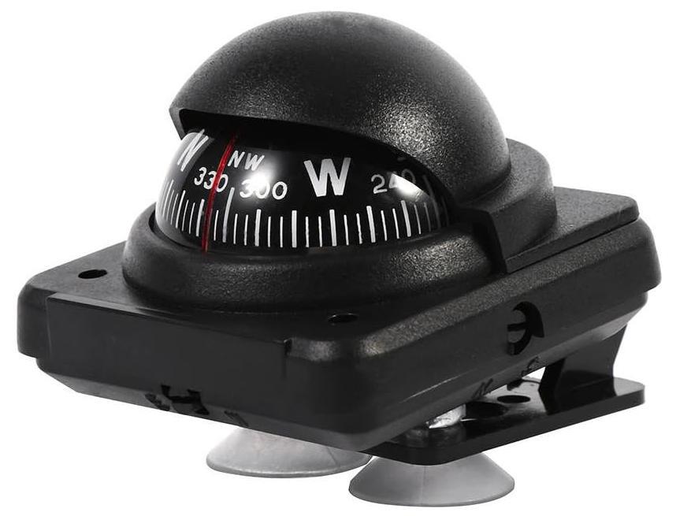

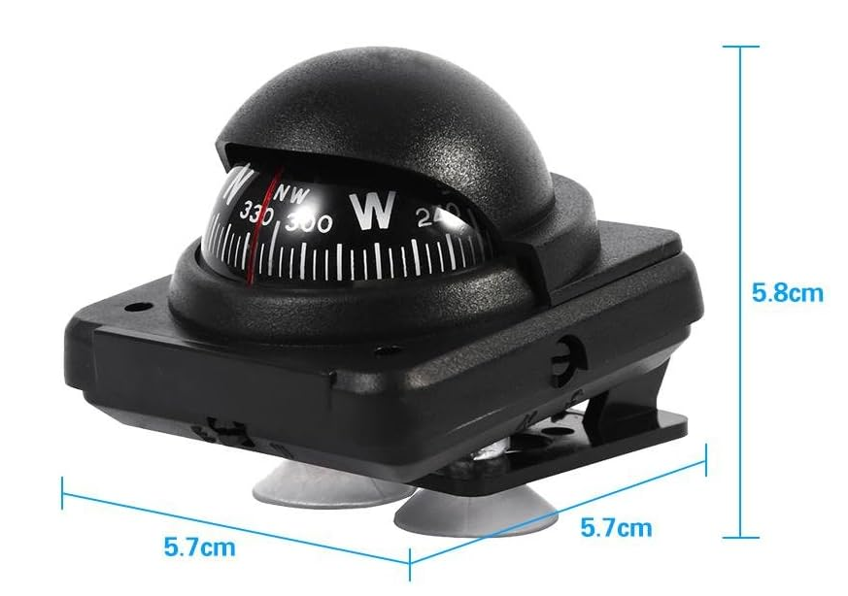

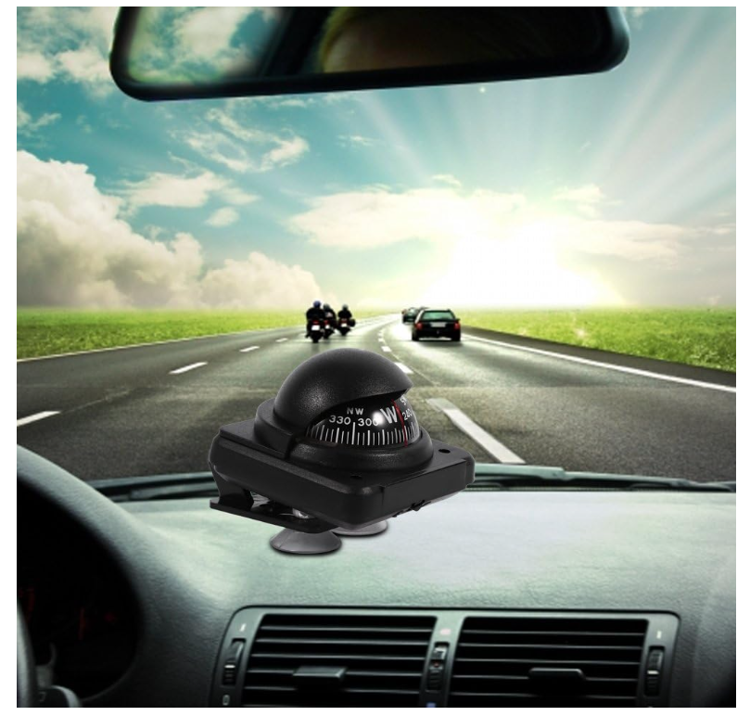

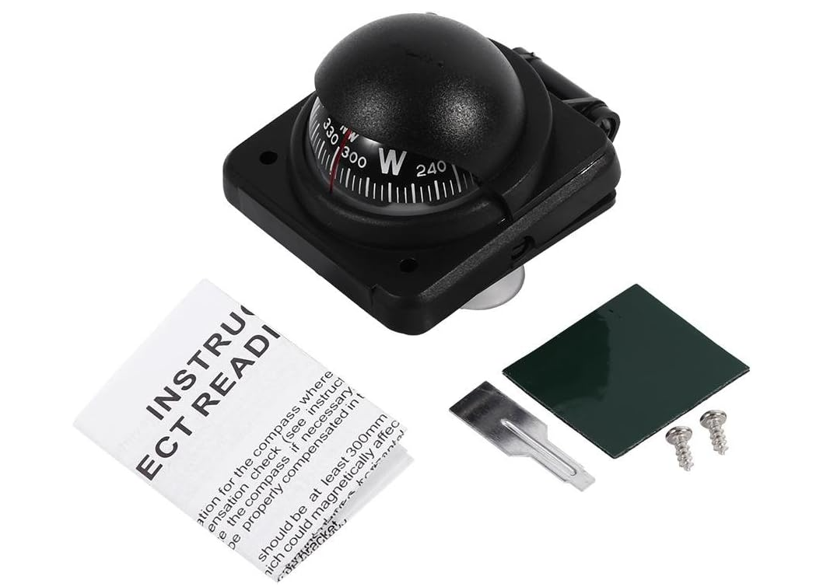

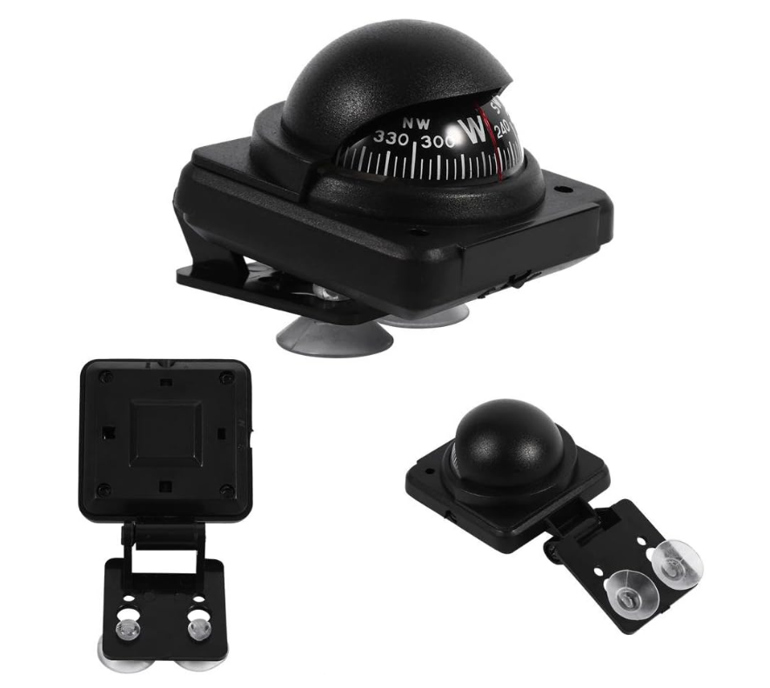

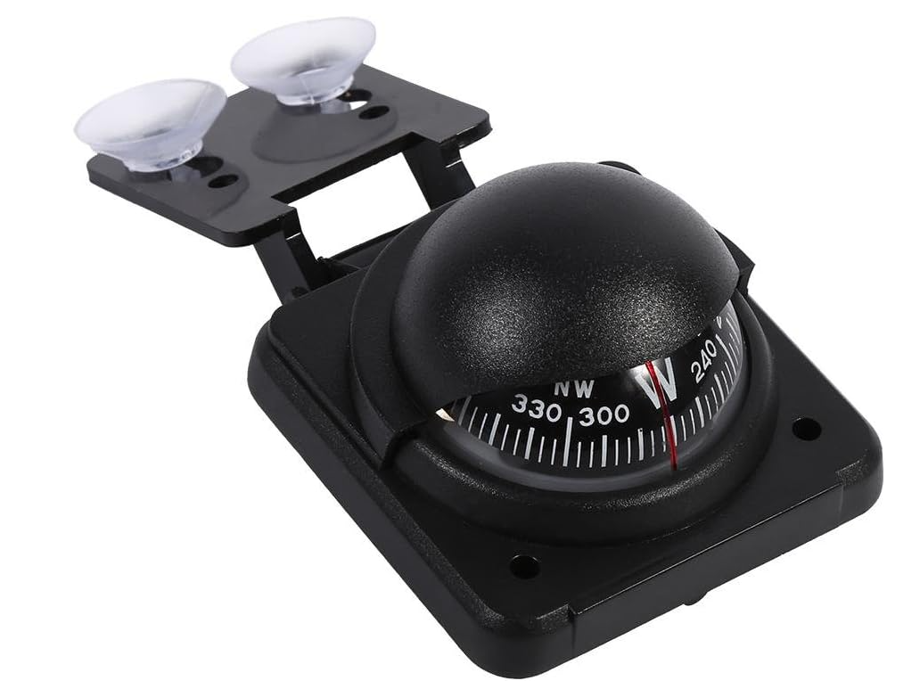

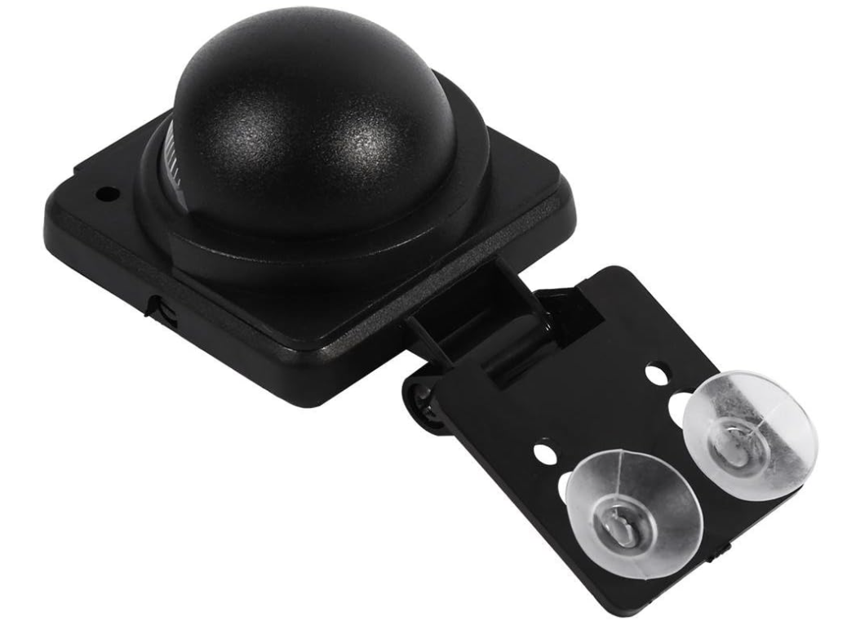

Clinometer

